`

**St Patrick’s Parish Bulletin**



***19th Sunday of the Year* –10th August 2025**

Parish Priest – Fr Ricklan Mallya CSSp

Assistant Priest – Fr James Flynn CSSp

Permanent Deacon – Harry McKenna

Tel. 01698 351921. [*stpatrickwishaw@rcdom.org.uk*](mailto:stpatrickwishaw@rcdom.org.uk)

Reg. Charity SC011041

Hall bookings and general enquiries: 07864711301

SSVP: 07927453236



**MASSES and SERVICES**

**Monday**

9.30 am Rosary

10.00 am Daily Mass

**Wednesday**

9.30 am Rosary

10.00 am Daily Mass

**Thursday**

9.30 am Rosary

10.00 am Funeral Mass for Jimmy Bohan (Buchan)

Vigil Mass 7.00pm

The Assumption of the Blessed Virgin Mary

**Friday**

**10.30am (please note)**

The Assumption of the Blessed Virgin Mary

**Saturday**

Vigil Mass 4.00 pm

**Sunday**

9.30 am Sunday Mass

Tuesday: St Clare

Thursday: St Maximilian Mary Kolbe

**Friday: THE ASSUMPTION OF THE BLESSED VIRGIN MARY**

**RIP**: Patrick McCafferty, Jimmy Bohan (Buchan), Grace O’Roure, Nancy Donnelly.

**MONTH’S MINDS & ANNIVERSARIES**: Paul Clark, Sam Beckett, Thomas McTear, Maureen McTear, Alice Fox.

**SICK**: Liz Phillips, Maureen Thompson, Janette Connor, Mary Jackson, John Dobbin, Marie McDonald, Roseleen Daly-Higgens, Theresa Gilgunn, Joseph Hawthorne, Ann Kenny, Margaret McCluskey, Dar Simpson, Kevin Kennedy, Theresa Frame, Gerry Hamil, Gerry McCann.

**BIRTHDAY REMEMBRANCE**: Janette Verrecchia.

**HOLY DAY OF OBLIGATION**

Friday August 15th is a Holy Day of Obligation (The Assumption of the Blessed Virgin Mary). The Vigil Mass on Thursday August 14th is at 7.00 pm and the Mass on Friday is at **10.30 am** (please note the change of the normal morning Mass time).



Cash Bingo every Wednesday. Eyes down at 7.30 pm. Come along and enjoy a chat a cup of tea and, of course, a game of Bingo! Everyone over the age of 18 years is most welcome to play.

**Visit our Parish Website**

[www.stpatricksshieldmuir.co.uk](http://www.stpatricksshieldmuir.co.uk)

Parish bulletins and other information will be uploaded here. **Please get in touch with Fr Mallya if you have notices for the website.**

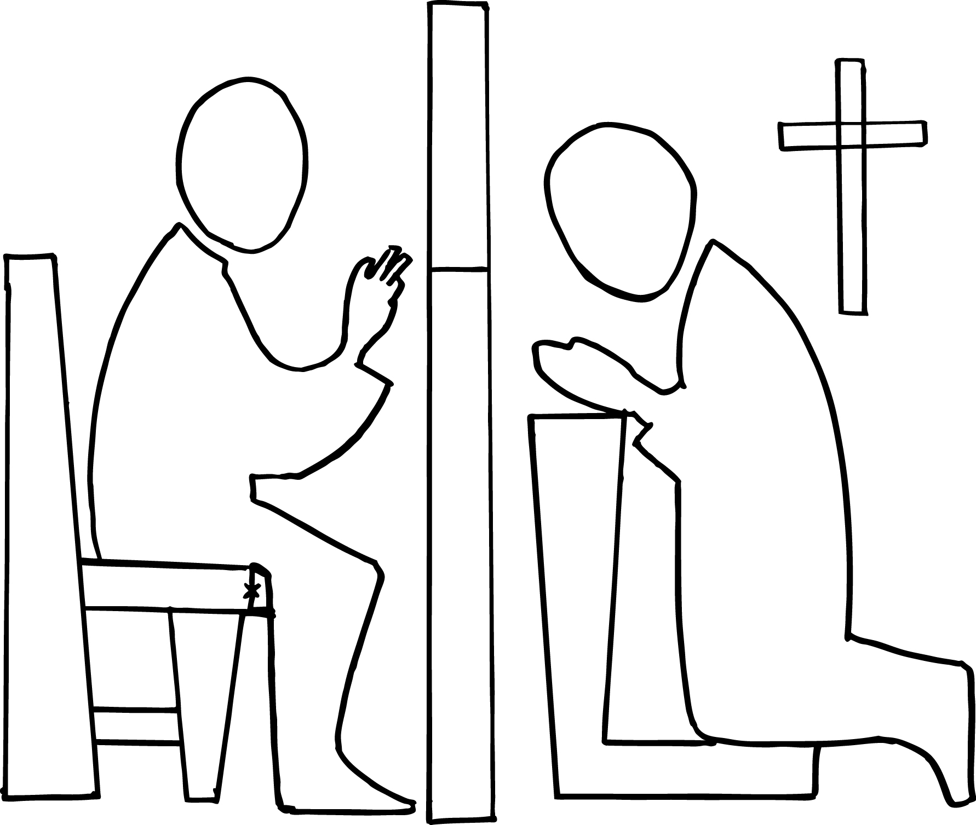

**Funeral Mass**

Jimmy Bohan (Buchan)’s remains will be received into the Church on Wednesday August 13th at 6.00 pm. His Funeral Mass will be on Thursday August 14th at 10.00 am.

**CONFESSIONS**

Thursday 9.30 am

Saturday 3.30 pm

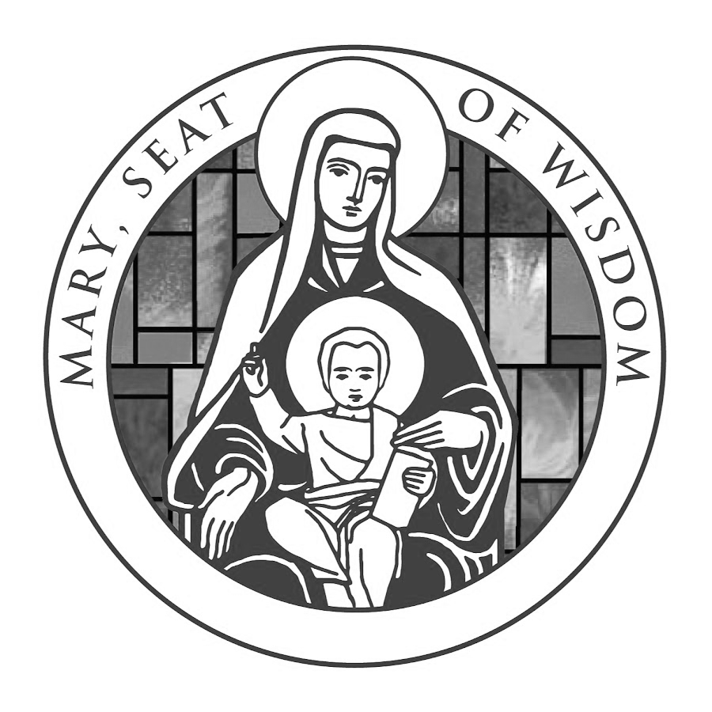 

**THANKSGIVING AND PRESENTATION MASS FOR FR JAMES**

Father James will be retiring at the end of August after 52 years serving God in the missions and parishes in the Diocese. A truly remarkable life! To show our appreciation of his time with us, we will be organising a thanksgiving Mass for him on Friday September 5th in St Patrick’s, Shieldmuir along with St Brendan’s and hopefully, St Bernadette’s. After this Mass, there will be a reception for him in the Parochial Hall. If you would like to contribute to his presentation, please use the box provided at the back of the Church. We will keep this box out for the next 3 weeks. Many thanks in anticipation.

**THANK YOU!**

Fr Ricky would like to take this opportunity to thank everyone for the kindness and generosity shown to him for the 25 years of his religious profession. Holy Mass will be offered for all your intentions.

THE CHARITY SHOP OPENS TUESDAYS AND THURSDAYS FROM 11.00 am UNTIL 2.00 pm. PLEASE COME ALONG AND SEE WHAT’S ON SALE. THERE ARE ALWAYS PLENTY OF BARGAINS ON OFFER!

Please continue your support by bringing food items to go to the food bank for the area. These items can be left in the box at the back of Church before each Mass.

As part of the 150th anniversary celebrations OLHS are hosting a fundraising dinner on 22nd August in Dalziel Park, when we will celebrate the life and history of the Our Lady's community past and present. The evening will be hosted by Peter Martin and includes a 3-course meal, drink on arrival, auction, raffles, games and disco. Tickets are £50. Please gather your old friends together, bring all your family members associated with the school and join us for a fantastic evening celebrating our *Alma mater*.  Tickets can be purchased via school, or email [olhs150dinner@gmail.com](mailto:olhs150dinner@gmail.com).

Bank transfers to sort code 80-09-15 Account no. 00693485 or from the school.

**PRAYER TO ST MICHAEL**

St Michael the Archangel, defend us in the day of battle. Be our safeguard against the wickedness and snares of the devil. May God rebuke him we humbly pray and do thou, O Prince of the heavenly hosts, by the power of God, case into hell Satan and all the other evil spirits who wander through the world, seeking the ruin of souls.

**PARISH INCOME**

Parish income: £841.19

Sort Code: 80 12 97

Account number: 10243263

**Visit our Parish Website**

[www.stpatricksshieldmuir.co.uk](http://www.stpatricksshieldmuir.co.uk)

Parish bulletins and other information will be uploaded here. **Please get in touch with Fr Mallya if you have notices for the website.**