`
St Patrick’s Parish Bulletin
4th Sunday of Advent – 21th December 2025
Parish Priest – Fr Ricklan Mallya CSSp
Assistant Priest – Fr Bernard Waave CSSp
Permanent Deacon – Harry McKenna
Tel. 01698 351921. stpatrickwishaw@rcdom.org.uk
Reg. Charity SC011041
Hall bookings and general enquiries: 07864711301
SSVP: 07927453236

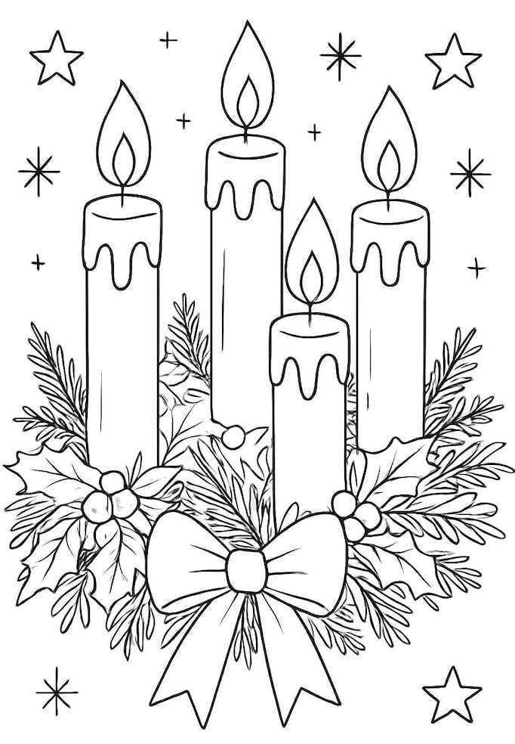
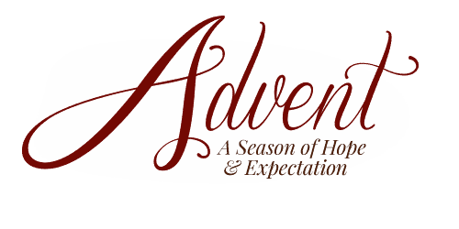


MASSES and SERVICES
Monday
9.30 am Rosary
10.00 am Daily Mass
Wednesday
9.30 am Rosary
10.00 am Daily Mass
Christmas Eve Mass 4.00 pm
Thursday
Christmas Morning Mass 9.30 am
Saturday
Vigil Mass 4.00 pm
Sunday
9.30 am Sunday Mass
Thursday: The Nativity of the Lord
Friday: St Stephen
Saturday: St John the Evangelist

RIP: Thomas Fisher, Ann Evans, Chris Ferris.
MONTH’S MINDS & ANNIVERSARIES: John Morton, Dora Carroll, James, Ellen and Joseph Winnie, Joseph, Elizabeth, Lizzie (Snr) Winnie, John Donnelly (Snr), Mary McGuinness, Alice Kelly McLaughlan, Alice Kelly, Fr John McNulty, Rose Mays, Charles, John and Hellen Felvus, Billy Higgins.
SICK: Liz Phillips, Maureen Thompson, Janette Connor, John Dobbin, Marie McDonald, Roseleen Daly-Higgens, Theresa Gilgunn, Joseph Hawthorne, Ann Kenny, Margaret McCluskey, Dar Simpson, Kevin Kennedy, Theresa Frame, Gerry Hamil, Gerry McCann.
BIRTHDAY REMEMBRANCE: Catherine McKenna

Mass on New Year’s Day 10.00 am
May we take this opportunity to thank everyone who has assisted in any way throughout the year within the Parish. We cannot do all the work without your valuable help. Please continue to support us in the years ahead. Thank you for the way in which you have opened your hearts to welcome Fr Bernard as Assistant to both St Patrick’s and St Brendan’s.

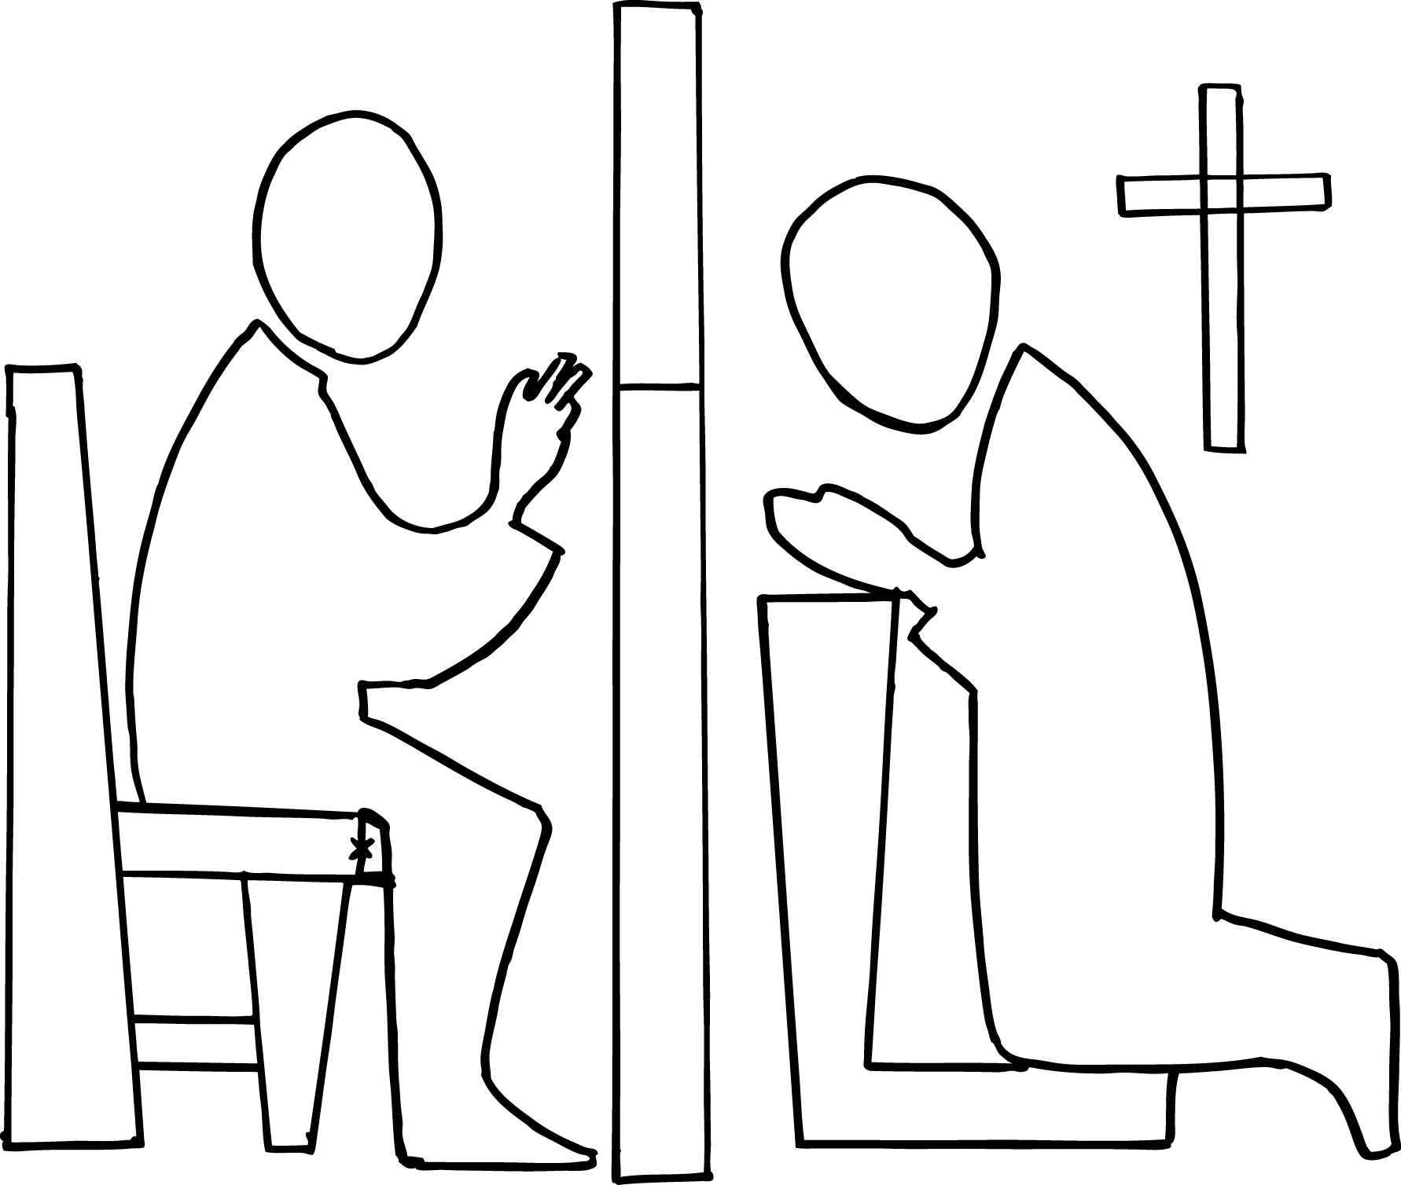
PRE-CHRISTMAS CONFESSIONS
Monday 22 10.00 am -12 pm and 6.00 pm – 7.00 pm

January 1st is the World Day of Prayer for Peace. There will be a second collection to support the work of Justice and Peace take up at the Christmas Masses. Please be as generous as you can because this collection goes a long way to supporting the Church throughout the year.


Cash Bingo every Wednesday. Eyes down at 7.30 pm. Come along and enjoy a chat a cup of tea and, of course, a game of Bingo! Everyone over the age of 18 years is most welcome to play.
Visit our Parish Website
www.stpatricksshieldmuir.co.uk
Parish bulletins and other information will be uploaded here. Please get in touch with Fr Mallya if you have notices for the website.
We thank the parishioners and wider community of St Patrick’s and St Brendan’s for the grace to draw ever closer to Jesus Christ, through our prayer, taking responsibility for our parishes and our charity to those more needy than ourselves, this Christmas and throughout the year ahead.
May God bless you all and we hope that you all have a very happy holy and peaceful Christmas.
Fr Ricklan, Fr Bernard and Deacon Harry.
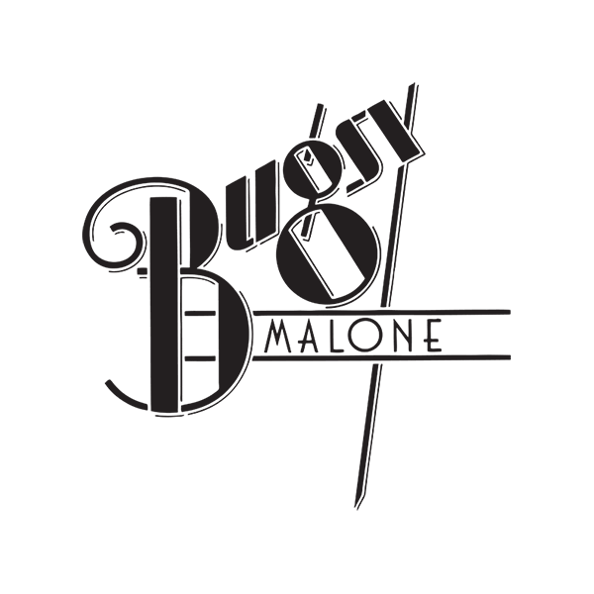


Visit our Parish Website
www.stpatricksshieldmuir.co.uk
Parish bulletins and other information will be uploaded here. Please get in touch with Fr Mallya if you have notices for the website.
PARISH INCOME

Parish income: £752.65
Sort Code: 80 12 97
Account number: 10243263

Dates for your diary
Parish Social Events
Hogmanay Party from
9.00 pm until 1.00 am
St Patrick’s Night Dance 14th March from 7.00 pm until 12 midnight.
Tickets priced £5.00 are on sale. Bring your own bottle and snacks
New year treat – blow away the winter blues with the musical Bugsy Malone. This takes place on Saturday 10th January at 2.30 pm in the Town House, Hamilton. It will be followed by high tea at the Wishaw Golf Club around 6.00 pm. Names with a deposit of £5.00 should be handed into the Stall. Times of bus departure will follow.
St Th

Jack and Francis Collins
Marie McLaghlin
Tommy and Margaret Dugan
Jan Logan
Bob Marks
Baby Luca Smith
Baby Leo Smith
James, Annie and John
Boyle
The Feenan family
The Boyle family
The McLaughlin family

Any late additions will be added to this list and published next weekend.
Eddie Brown
Cathy Moore
Frank Cunningham
James and Fanny Sarah Brown
Terence Kelly
Rose Lee
Pat and Grace McCready
Jim and Molly McKenna
James and Annie Haley
Bill and Jean Carter
Charlie Gorman
John McGuinness
The Kelly family
The Plunkett family
The Bamford family
Gemma McKeown
Maria Murphy
Tony, Mary and Rosemary
McCafferty

A huge thanks to everyone in the Parish who has worked so hard to have our Church ready for Christmas!

New year treat – blow away the winter blues with the musical Bugsy Malone. This takes place on Saturday 10th January at 2.30 pm in the Town House, Hamilton. It will be followed by high tea at the Wishaw Golf Club around 6.00 pm. Names with a deposit of £5.00 should be handed into the Stall. Times of bus departure will follow.
Dates for your diary
Parish Social Events
Hogmanay Party from
9.00 pm until 1.00 am
St Patrick’s Night Dance 14th March from 7.00 pm until 12 midnight.
Tickets priced £5.00 are on sale. Bring your own bottle and snacks

For all who have put their names forward to join our 200 Club, you can pick an envelope marked “200 Club” at the back of the Church. Please take one, put your name and contact number on this and enclose the £12.00 subscription per number. Please hand this in to the Stall by 17/18 January. If you have not already joined but would like to, please take an extra number, put your name and contact number on the sheet at the back of the Church along with an envelope with your details and contribution.
PARISH INCOME

Parish income: £752.65
Sort Code: 80 12 97
Account number: 10243263

